**DAY 4**

1.     List all customers and the products they ordered with the order date. (Inner join)

**Tables used:** customers, orders, order_details, products

**Output should have below columns:**

    companyname AS customer,

    orderid,

    productname,

    quantity,

    orderdate

2. Show each order with customer, employee, shipper, and product info — even if some parts are missing. (Left Join)

Tables used: orders, customers, employees, shippers, order_details, products

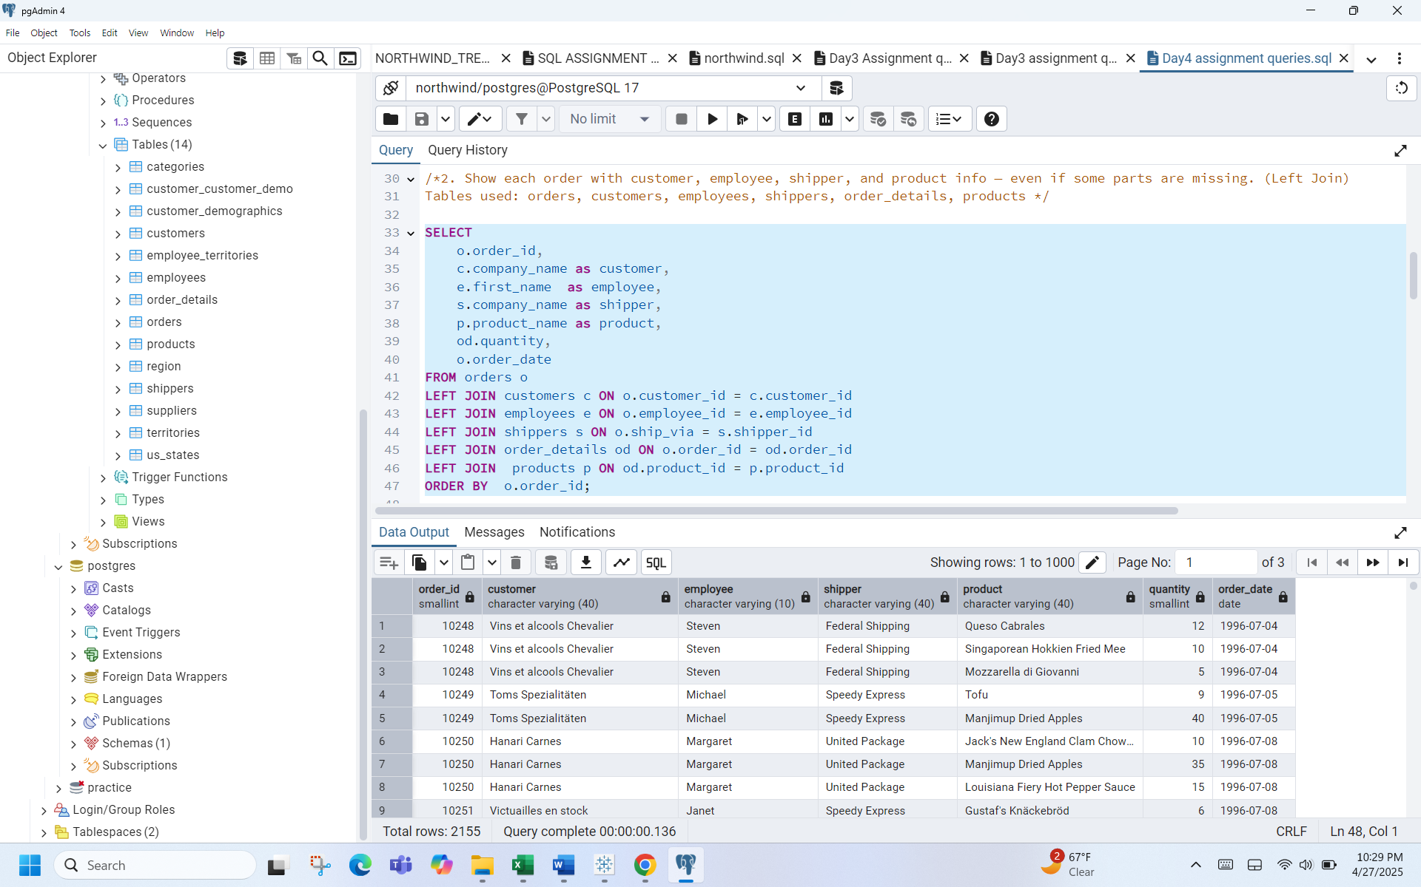

/*3.Show all order details and products (include all products even if they were never ordered). (Right Join)

Tables used: order_details, products

Output should have below columns:

orderid,

productid,

quantity,

productname */

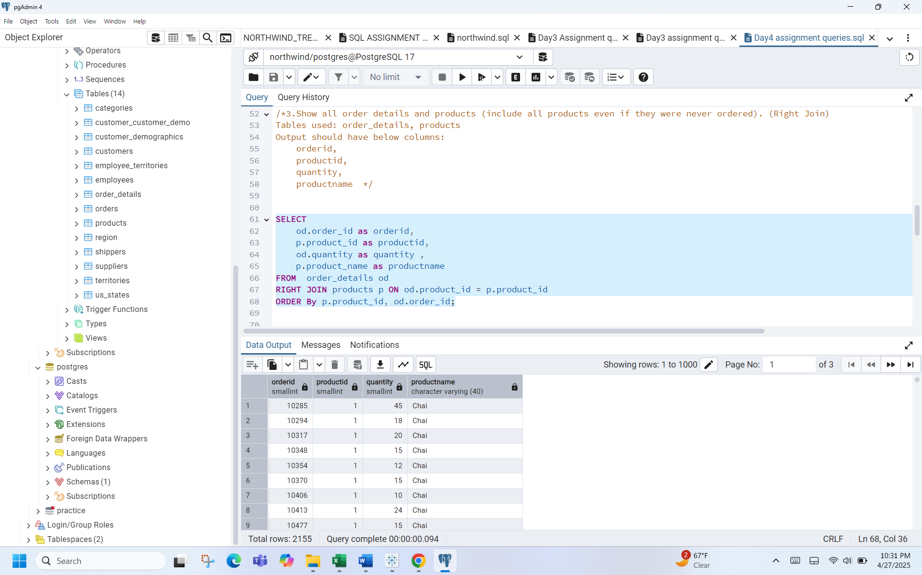

4.List all product categories and their products — including categories that have no products, and products that are not assigned to any category.(Outer Join)

Tables used: categories, products

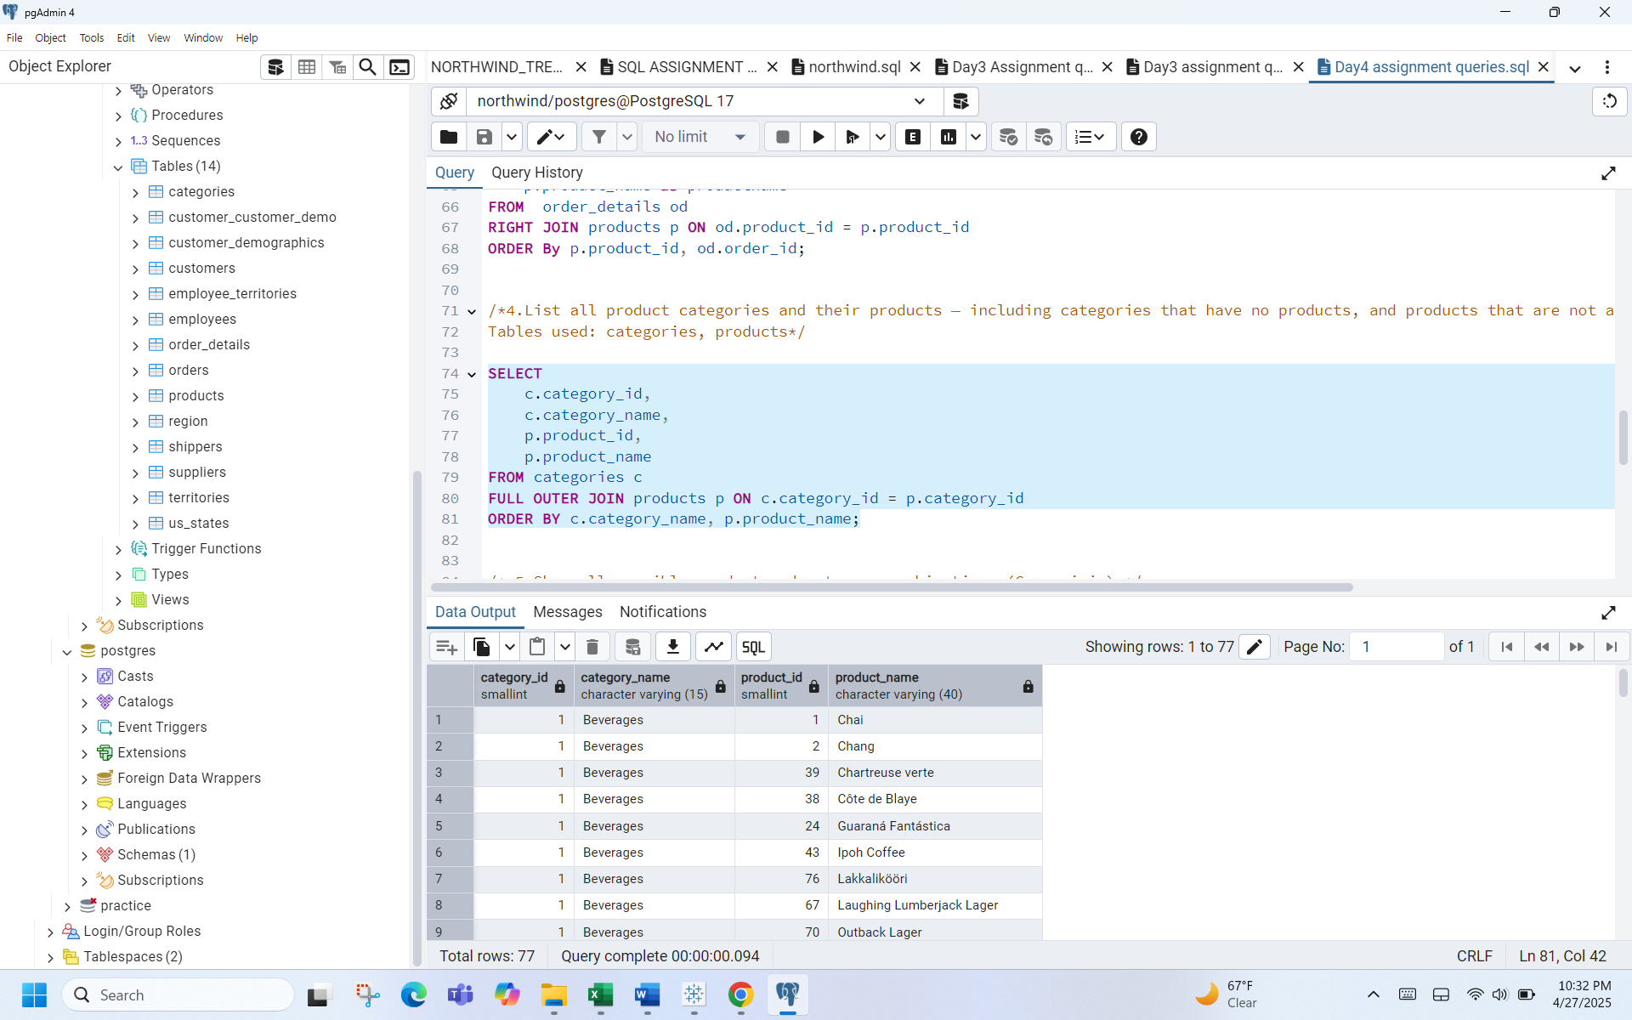

5.Show all possible product and category combinations (Cross join)

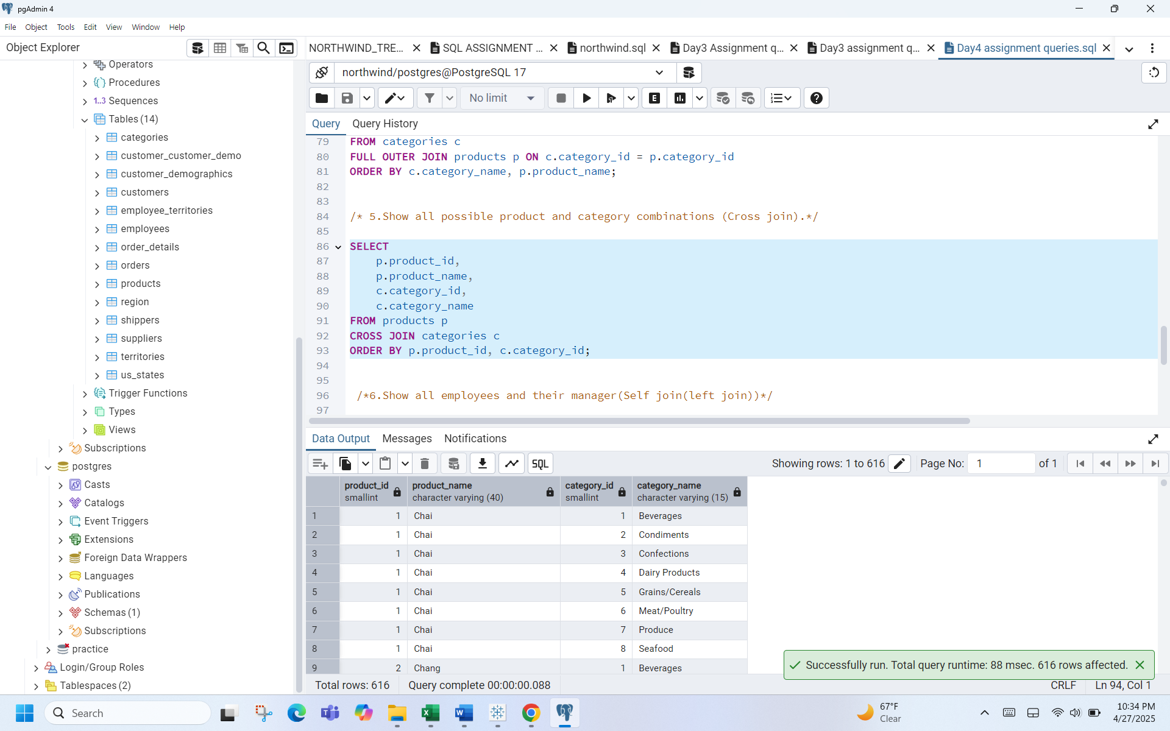

6.Show all employees and their manager(Self join(left join)

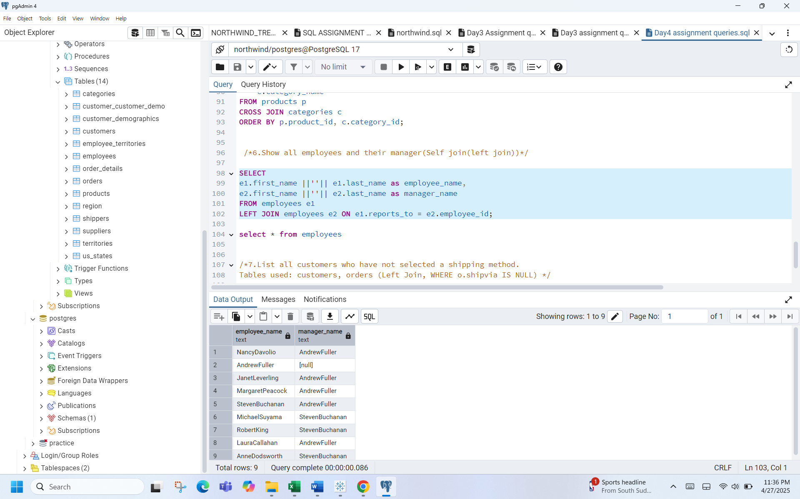

7.List all customers who have not selected a shipping method.

Tables used: customers, orders (Left Join, WHERE o.shipvia IS NULL)

